**R PROGRAMMING**

Ques 6 . Load the built-in iris dataset and write the R commands/script for the following:

a.Display the summary statistics for all the variables in the dataset.

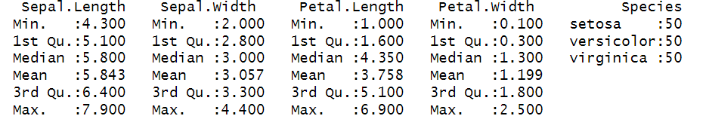

b. Plot a scatter plot for Sepal length and Sepal width for the species “setosa”.

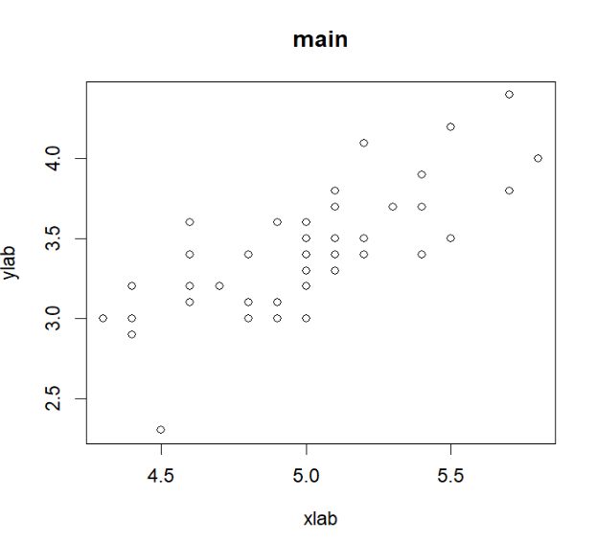

c. Annotate the above graph (a) with appropriate X-axis, Y-axis labels and Main title.

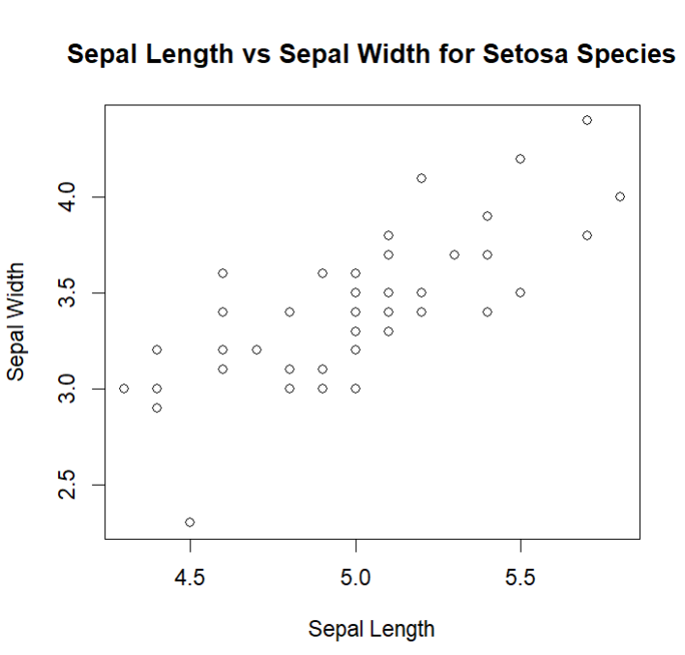*Output will be same as b part just names of axis and title will be changed. *

d. Plot a histogram for the variable Petal.length .

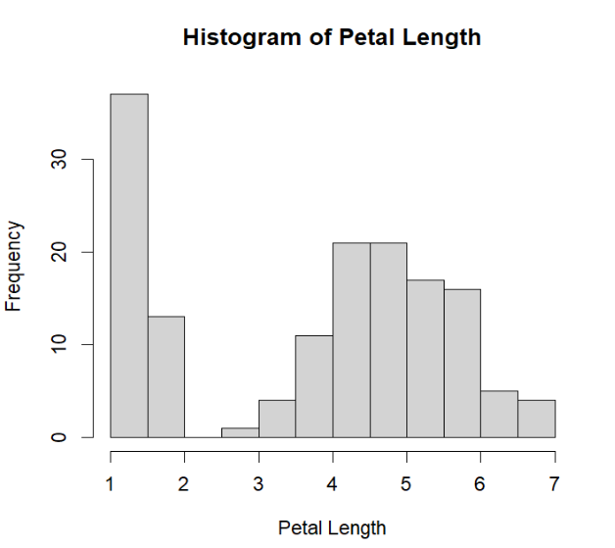

e. Create a boxplot for Petal width of Species=versicolor.

